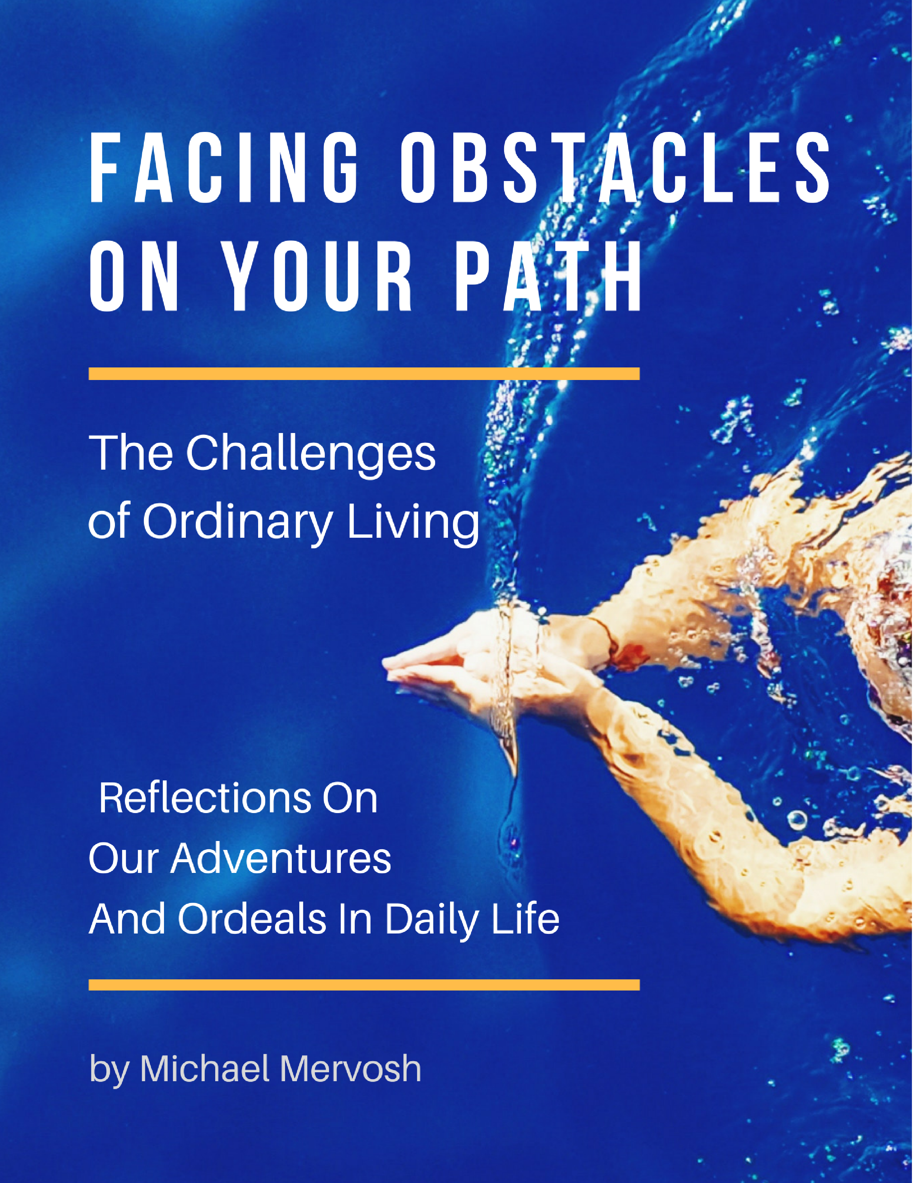

Facing Obstacles On Your Path

The Challenges of Ordinary Living:
Reflections on Our Adventures & Ordeals in Daily Life

By Michael Mervosh

Try to love everything that gets in your way;
The Chinese women in flowered bathing caps murmuring
together in Mandarin and doing leg exercises in your lane
while you execute thirty-six furious laps,
one for every item on your to-do list.

The heavy-bellied man who goes thrashing through the water
like a horse with a harpoon stuck in its side and
whose breathless tsunamis rock you from your course.
Teachers all.

Learn to be small
and swim past obstacles like a minnow,
without grudges or memory. Dart
toward your goal, sperm to egg. Thinking, Obstacle,
is another obstacle.

Try to love the teenage girl
lounging against the ladder, showing off her new tattoo:
Cette vie est la mienne, This life is mine,
in thick blue-black letters on her ivory instep.
Be glad she'll have that to look at the rest of her life, and
keep going.

Swim by an uncle in the lane next to yours
who is teaching his nephew
how to hold his breath underwater,
even though kids aren't supposed
to be in the pool at this hour.

Someday, years from now, this boy
who is kicking and flailing in the exact place
you want to touch and turn
may be a young man at a wedding on a boat,
raising his champagne glass in a toast
when a huge wave hits, washing everyone overboard.
He'll come up coughing and spitting like he is now,
but he'll come up like a cork, alive.

So your moment of impatience
must bow in service to the larger story,
because if something is in your way, it is
going your way, the way
of all beings: toward darkness, toward light. 1

- Alison Luterman

I recently stumbled back onto this churning poem by Alison Luterman. She found her obstacle during her everyday routine of swimming laps in the local pool. Her creative imaginings were born from her experience of various people in the water before her. She finds a way to engage with what is put in her way in the form of her fluid perceptions, as she makes her way across the pool.

Try to love everything that gets in your way;
The Chinese women in flowered bathing caps murmuring
together in Mandarin and doing leg exercises in your lane
while you execute thirty-six furious laps,
one for every item on your to-do list.

Her imaginings in this particular poem linger within the deeper waters of my own psyche. They challenge me to explore a new way to consider maneuvering through this world, and by doing so, to let go of some chronic and fixed habits.

Take, for instance, my ability to whine about every little thing that tends to get in front of me while I go along my way in daily life: the morning traffic; the expectations of others; the frenetic pace of a jammed schedule; the latest ‘to do’ list; an old resentment that creeps back from the darker corners of my mind.

I am remembering a few years back, having just completed a week of intensive PsychoEnergetics training in our communal, cocoon-like learning environment that sits alongside a quiet seaside town in Costa Brava, Spain. We had been nicely settled in for a time, resting right up against the beautiful deep blue waters of the Mediterranean.

Having departed from that setting, I was being dropped off at the Barcelona airport by my kindly, attentive driver. I stepped out into the cool, early morning light with plenty of time to spare. I sleepily ambled into the sea of humanity floating by, navigating lanes of travelers, the background noises humming along to the tune of roller wheels. Then, in the next few minutes, I found I was stranded.

The heavy-bellied man who goes thrashing through the water
like a horse with a harpoon stuck in its side and
whose breathless tsunamis rock you from your course.

All of a sudden, I had my version of a heavy-bellied obstacle splashing big waves in my travel lane. Volcanic ash had been drifting over Spain and Portugal from Iceland, near to the Barcelona airport. The plane that I was to board was maybe still sitting in the US, maybe in the air. Rocked from my course.

Teachers, all.

Talking to fellow travelers, I discover that others had had the same problem the day before – and didn’t get to board their plane. Here they were again today, attempting another departure. I’d had the urge to check my emails before leaving for the airport, but I didn’t. So now I check my email while standing in a long line of travelers. I had four messages from the airline, each one lengthening the delay.

Learn to be small
and swim past obstacles like a minnow,
without grudges or memory.

Okay. Practicing mindfulness, I see my plans have changed. The agent gives me a ticket for a connecting flight, the last flight out of Philadelphia. Says maybe I will make this flight, maybe not. No clear information to be had. I have a seat in the main terminal; I am told to check back in the late afternoon. I am swimming along now, feeling more and more like a minnow in a large sea of air travelers.

Without grudges.

Just don’t engage the reflexive grudge, the easiest feeling available, or other rising feelings such as anxiety, or restless agitation. Fair enough. I head for security. I search for my boarding pass for the necessary gate information, before entering the security area to get clearance to go to the gate. Now I realize I have somehow lost my boarding pass in the sea of humanity.

Thinking ‘obstacle’ is another obstacle.

I head back to the check in counter. I am splashing around in my mind, swimming at a faster pace in my travel lane now. I sheepishly explain to the ticket agent my lost-ness, learning to be small. They simply hand me another ticket. This minnow thing seems to be working.

Going through security, my boarding pass does not pass the scanner. It keeps beeping and flashing red. The security personnel says something to me in Spanish and points to my ticket. I stare at him blankly. He just waves me on. Yep, swimming past obstacles like a minnow…

Try to love the teenage girl
lounging against the ladder, showing off her new tattoo:
Cette vie est la mienne, This life is mine,
in thick blue-black letters on her ivory instep.
Be glad she'll have that to look at the rest of her life, and
keep going.

I spend hours on end in the Barcelona airport. I Skype with a few friends and colleagues, I praise the wonders of the airport’s web server. Now I’m doing the backstroke with technology, buoyant with a sense of adventure and connection, going with my little ordeal of being inconvenienced.

I think to myself, this is my life; this is what’s happening now. This life is mine. I feel into people and connections that I can be with right now, right in front of me. These are people that I can swim with for a little while, keep one another’s company briefly, and just keep going.

Barcelona has an outdoor pavilion for its travelers to get some fresh air and sun. The space is beautifully spare and quiet. This is not like most airports in the United States. I enjoy the quiet. Next to me a few young women, heavily tattooed, rest against each other on the same section of the pavilion as me. They lounge and quietly laugh with each other. I wonder, where are they going? Will all of those tattoos age well as they grow older?

This allows me to recall my grandmother’s sister, back when I was a young boy. She had a tattoo, many decades before women took up that pursuit. What a character she was. Swimming through memories now….

Swim by an uncle
in the lane next to yours who is teaching his nephew
how to hold his breath underwater…

I arrive at my departure gate at a newly designated time. No one is there. No airline representatives; just a handful of travelers. No announcements. I see what appears to be our plane, just sitting out there on the tarmac. It is not pulling up to the gate. I find myself holding my breath again.
Spotting an airport security person, I ask him what’s happening. He is very friendly. He is even riding a Segway. Now that looks kind of peculiar, but fun. He propels away to explore what is happening with the plane. I think to myself, how minnow-y he is. In the mean time, I keep afloat with Skype, connecting with friends. I read The New Yorker magazine. I stay swimming in my own lane.
The airport personnel are all very friendly. This is different from my typical experience in the States. These people are not really very helpful in finding out relevant information about my flight, but I like how they all get interested in the matter at hand. Or maybe they just like to be a part of small group conversation. In any event, no one really finds out anything of use. But their friendliness seems to swim right past the lack of information. I decide to just keep swimming like this for a while longer.

Someday,
years from now, this boy
who is kicking and flailing in the exact place
you want to touch and turn
may be a young man at a wedding on a boat

Perspective. Kicking and flailing - as all of us do at some point, in the uncertain waters of life. It’s time to stop trying to get answers. It’s time to start getting more curious about the people who are happening right in front of me. I try looking more into their eyes, and see the human-ness in their faces, and in their helpful intentions.

Time keeps passing by; still no airline personnel; still no announcements or new information. I go to the friendly Segway rider guy again, he gets on a phone. He says the plane is going to be departing today, most definitely at some point, at least he thinks so, as far as he can tell. Somehow, this news feels reassuring. I am not kicking and flailing so much; nothing seems to be in my way at the moment.

I find myself moving within the fluid-like way he has of saying he really isn’t sure of anything. I ask him instead about what it is like to ride the Segway. He talks about how he really likes it. I decide against asking if I can have a ride.

when a huge wave hits, washing everyone overboard.
He'll come up coughing and spitting like he is now,
but he'll come up like a cork,
alive.

More time passes. Many security personnel have arrived. Lots of radios talking white noise, with staff standing around, acting job-like. The other passengers all seem content enough; no one else is kicking and flailing for fresh information. There are announcements, from time to time, that we will be boarding soon. We don’t. But we all seem to keep coming up like corks, after each new delay.

Finally, we begin boarding. No explanation about the delays, yet no splashing about by the passengers. I am definitely riding a European wave. We prepare to board the plane. Another delay, no explanations necessary now. We all just wait, bobbing like corks, outside the door of the aircraft. Then we sit a long time on the runway before departing.

At last, I am completely accepting what is, as it comes; I am no longer undone or deadened by the perception of delays. I am alive in my life as it is happening.

On the flight home, we are re-routed directly over Iceland, right as the sun is setting on the icy continent. The pilot comes over the speakers, says that we can see the volcano pluming smoke if we look out the left side of the airplane. I have a left side seat, so I share my view with others. We all take turns watching the plume rise; we are snapping photos with camera phones. I am content watching the heavy-bellied volcanic ash rise into the vast sky. My obstacle looks beautiful and small from way up here. Perspective.

We all continue to partake in seat exchanges for the next half hour, passing over Iceland, and the light slowly fades from red-orange, and we fly into the blue-grey night.

So your moment
of impatience must bow in service to the larger story,
because if something is in your way, it is
going your way, the way
of all beings: toward darkness, toward light.

Tired and worn by the time spent waiting, sitting and not exactly sleeping,
we arrive in Philadelphia, 1:00am. New boarding passes for the next day’s flight, then hotel and meal vouchers passed along quickly to each of us with connecting flights. I travel lightly on these trips, with only carry on luggage, so I move quickly through customs, through the airline representatives who expedite my departure to the hotel.

Swimming nicely in my lane.

I overhear the airline crew saying that the ground crew isn’t able to get the plane’s baggage doors open on the plane I just departed. Oh well, that will not be my obstacle for tonight. I usher myself onto the hotel shuttle along with the airline crew, and begin re-arranging my appointments for the next day. Somehow, this small opening in the travel lane of my life makes everything feel like it is now going my way. I again feel part of the larger pool of air travelers.

Then, more acutely, I feel a connection to the larger story of those with no option of travel, those stranded in their home countries, in harsh poverty, in oppression, in circumstances far from swimming pools. I feel for those whose governments block the lanes of freedom, of air travel. There are matters far more dire than volcanic ash disrupting the lanes in their lives.

I complete this bit of writing from my new swimming lane: seat 13C. I’m sitting on the tarmac on a typically busy weekday morning on the Philadelphia runway. Waiting once more. Phila-delay-phia. Becoming once more small, like a minnow, bowing in service to stories larger than my own schedule and plans.

Try to love everything that gets in your way…
because if something is in your way, it is
going your way, the way
of all beings: toward darkness, toward light.

I keep swimming back and forth between the first verse and final passage of Luterman’s poem, like bookends. The final passage is cataclysmic; it has impact. It keeps touching me, turning the corner from dark to light. Because if something is in my way, it is going my way. What if that could be? What if that is?

This turn of perspective changes something within me. I am going the way of all beings: towards darkness, then towards the light again, and yet again. With each turn towards the dark – in solid form perhaps an obstacle - but in its very essence the darkness is just a doorway to a larger sense of mystery, evoking possibility within its unknown terrain, even wonder and awe.

With each turn towards the light – there is more life, more vitality, more of a felt sense of real self – born as always, from the dark. Then going beyond that, to the joy of the light itself. I am out of my own way. When that happens, life itself goes with me, going my way.

Time to wrap up this swim. We are number two for departure.

- Michael Mervosh

1. Used with permission by the author. For more information and poetry, please visit alisonluterman.net.

